**Total number of Goals in Montevideo: 70**

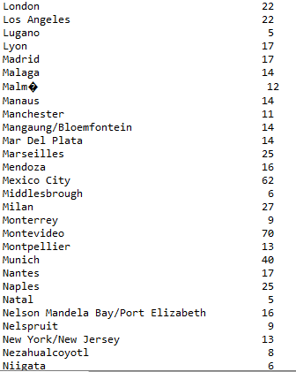

**Total number of referee assigned in Argentina: 49**

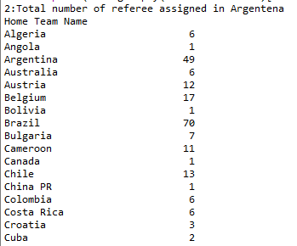

**Maximum number of Goals scored by hometeam: 10**

